**SMOKE DETECTION WITH FIRE PREVENTION**

A COMPUTER NETWORKS PROJECT REPORT

BY

**NAYANI NAMRATHA (RA1911028010143)**

**GOWTHAMI PRIYA (RA1911028010140)**

**SATHWIKA ROY (RA1911028010132)**

Under the guidance of

Subject Handling **Dr.P. Balamurugan**

In partial fulfilment for the Course

of

18CSC302J - COMPUTER NETWORKS

in

Department Name



FACULTY OF ENGINEERING AND TECHNOLOGY  SRM INSTITUTE OF SCIENCE AND TECHNOLOGY  Kattankulathur, Chenpalpattu District

NOVEMBER 2021

SRM INSTITUTE OF SCIENCE AND TECHNOLOGY

(Under Section 3 of UGC Act, 1956)

BONAFIDE CERTIFICATE

Certified that this project report "Project Title " is the bonafide work Of **NayaniNamratha(RA1911028010143),GowthamiPriya(RA1911028010140), Sathwika Roy(RA1911028010132)** who carried out the project work under my  supervision.

SIGNATURE SIGNATURE

Subject Staff Dr.E. Sasikala,

Designation Course Cordinator

Department Associate Professor,

SRM Institute of Science and Technology Data Science and Business Systems

Potheri, SRM Nagar, Kattankulathur SRM Institute of Science and Technology

Tamil Nadu 603203 Potheri, SRM Nagar, Kattankulathur,

Tamil Nadu 603203

**ACKNOWLEDGEMENT**

 We express our heartfelt thanks to our honorable **Vice Chancellor Dr. C. MUTHAMIZHCHELVAN**, for being the beacon in all our endeavors.

We would like to express my warmth of gratitude to **our Registrar  Dr. S. Ponnusamy,** for his encouragement

 We express our profound gratitude to **our Dean (College of  Engineering and Technology) Dr. T. V.Gopal**, for bringing out novelty in all  executions.

 We would like to express my heartfelt thanks to Chairperson, School  of Computing **Dr. Revathi Venkataraman**, for imparting confidence to  complete my course project

We wish to express my sincere thanks to **Course Audit Professor  Dr.M.LAKSHMI, Professor and Head, Data Science and Business Systems  and Course Cordinator Dr.E. Sasikala, Associate Professor, Data Science and Business Systems** for their constant encouragement and support.

 We are highly thankful to our my Course project Internal guide  **Subject handling staff name , Designation , Department**, for his/her assistance, timely suggestion and guidance throughout the duration of this course  project.

 We extend my gratitude to **Student HOD name Department** and my Departmental colleagues for their Support.

 Finally, we thank our parents and friends near and dear ones who directly and indirectly contributed to the successful completion of our project.  Above all, I thank the almighty for showering his blessings on me to complete my Course project

**TABLE OF CONTENTS**

* ABSTRACT
* INTRODUCTION
* REQUIREMENTS
* ARCHITECTURE AND DESIGN
* IMPLEMENTATION
* TESTING AND ANALYSIS
* REFRENCES

**ABSTRACT**

Environment has been deeply harmed by humans since a great deal of time, but with the technological advancements we can try and heal it. Detection of fire in homes is necessary to avoid destruction of property due to fire accidents both natural and induced. Detection of fire can prove to be very important as it could mean the difference between life and death. Fires can occur from anywhere and at any point of time, hence the presence of Fire Alarm System helps in keeping your family safe. An automatic smoke detecting system will notify the individual as well as take necessary actions in the home in order to prevent the fire from spreading. It will help in detecting fire or smoke at an early stage and can help in saving lives. In our proposed system we are making use of Internet of Things as the technology and though a smoke sensor we will notify various home equipments to take appropriate actions in order to stop the fire from spreading. The system is beneficial as it not just buzzes an alarm but also alerts the home appliances to do as they are needed

**INTRODUCTION**

## 2.1 Motivation

Fire is very deadly and it leads to loss of human life and property. Fire detection systems are necessary to reduce the destruction of personal belongings and caused by fire both man made and induced. One of the most destructive properties of fire is that it spreads exponentially and with the right medium can spread uncontrollably. This is why timely detection of fire is necessary for avoiding a fire hazard. The Internet of Things is a collection of sensor, actuators, software, electronics embedded with home appliances, physical devices and vehicles which connect with each other to connect and exchange date which helps in increasing the efficiency of everyday appliances using computer-based systems.

**2.2 Problem Definition**

Fires cause serious damage and disrupts daily life in a devastating manner. Hence preventing them or reducing their effects is a top priority. Though there are many systems that have been created to tackle this problem, false alarms are a challenge that is yet to be avoided. Our model, using smoke sensors alerts all the home appliances so that they can take their appropriate actions. The appliances that will be alerted are doors, windows, sprinklers, garage doors etc.

**2.3** **Scope**

Our model, consisting of the smoke sensor has been conditioned to a limit of 0.5; which implies that if the smoke level detected by the sensor reaches more than the level set, appropriate actions will be taken. This can be changes according to the desire of the individual, situation or surroundings. Furthermore, there are a limited set of appliances that are prompted by the smoke sensor; which can be changed. Windows, doors and garage doors open when the smoke level exceeds the given level. The sprinklers too start spraying water in order to prevent the spread of fire in the household.

REQUIREMENTS

* 1. **Project Implementation Schedule**

*Table 2.1. Project Implementation Schedule*

|  |  |  |  |  |
| --- | --- | --- | --- | --- |
| Sr no. | Task Name | Duration | Start Date | End Date |
| 1 | Planning | 10 days | 14-09-2021 | 24-09-2021 |
| 2 | Design | 10 days | 25-09-2021 | 05-10-2021 |
| 3 | Implementation | 15 days | 06-10-2021 | 20-10-2021 |
| 4 | Testing | 6 days | 21-10-2021 | 26-10-2021 |

The duration of the project was 6 weeks. So, the first 10 days were allocated for planning of the project. The planning included what topics to be covered and which components will be required for the project to be completed. Also, the flow of the tasks was also decided in the planning phase. Then, 10 days were allocated for the designing phase. In this phase, the architecture of the system was developed. We designed the architecture for our Wireless Network. The connection of the devices was drawn out visually. The next part was the implementation part to which we allocated 15 days. In the implementation part, we created our project in the Cisco Packet Tracer. We created a network and made the configurations as required. We had to make changes several times before we finally developed the complete system. The last 6 days were allocated for the testing of the developed system. In this phase, we created many test cases based on our system. These test cases were then checked in the system to get a result on whether the system is performing as desired or is there any malfunction. The test cases were covered for almost all the modules in the project.

Our Smoke detection and fire prevention project was implemented on Cisco packet tracer for testing. Components used for our project are as follows:

* + - **Home Gateway**: A router that forwards the data to the server and the control information to the connected devices for alerting purposes and hence allows it to take necessary actions to extinguish the fire.
    - **Door**: Affects Argon, Carbon Monoxide, Carbon Dioxide, Hydrogen, Helium, Methane, Nitrogen, O2, Ozone, Propane, and Smoke. When the door is opened, those gases will decrease to a maximum of 2% in total change. When the door is opened, the rate of transference for Humidity and Temperature is increased by 25%. The rate of transference for gases is increased by 100%
    - **Smoke Detector**: Detects Smoke. Alarm will go off when it detects the environment variable SMOKE at the level of 40%.
    - **Fire Sprinkler**: Raises the water level. Affects Water Level at a rate of 0.1 cm per second. This is connected to the smoke detector.
    - **Siren:** Makes a loud emergency noise when activated. It is activated when certain conditions are encountered.
    - **Garage Door**: Affects Argon, Carbon Monoxide, Carbon Dioxide, Hydrogen, Helium, Methane, Nitrogen, O2, Ozone, Propane, and Smoke. When the door is opened, those gases will decrease to a maximum of 4% in total change. When the door is opened, the rate of transference for Humidity and Temperature is increased by 50%. The rate of transference for gases is increased by 100%.
    - **Smartphone**: This is the user interface that allows the user to know that a fire occurred at their place with the help of the application running on their smartphone and the amount of smoke generated and hence take necessary steps. • Window: A window is an opening in a wall, door, roof or vehicle that allows the passage of light, sound, and sometimes air.

**ARCHITECTURE AND DESIGN**

* 1. **Construction and Design** 
     1. **Navigation**

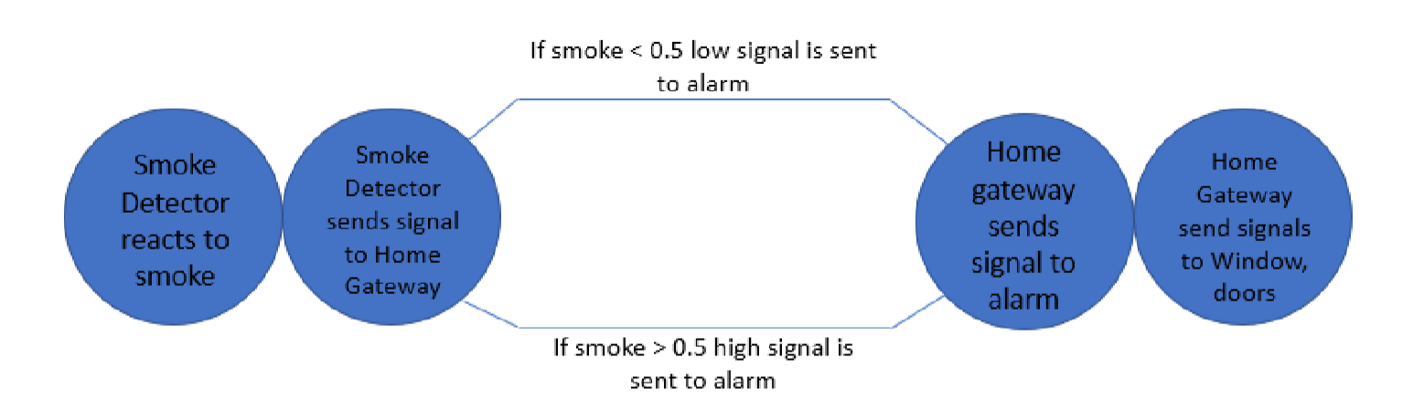

*Figure 4.1. Smoke Detector*

* + 1. **Page Layout**

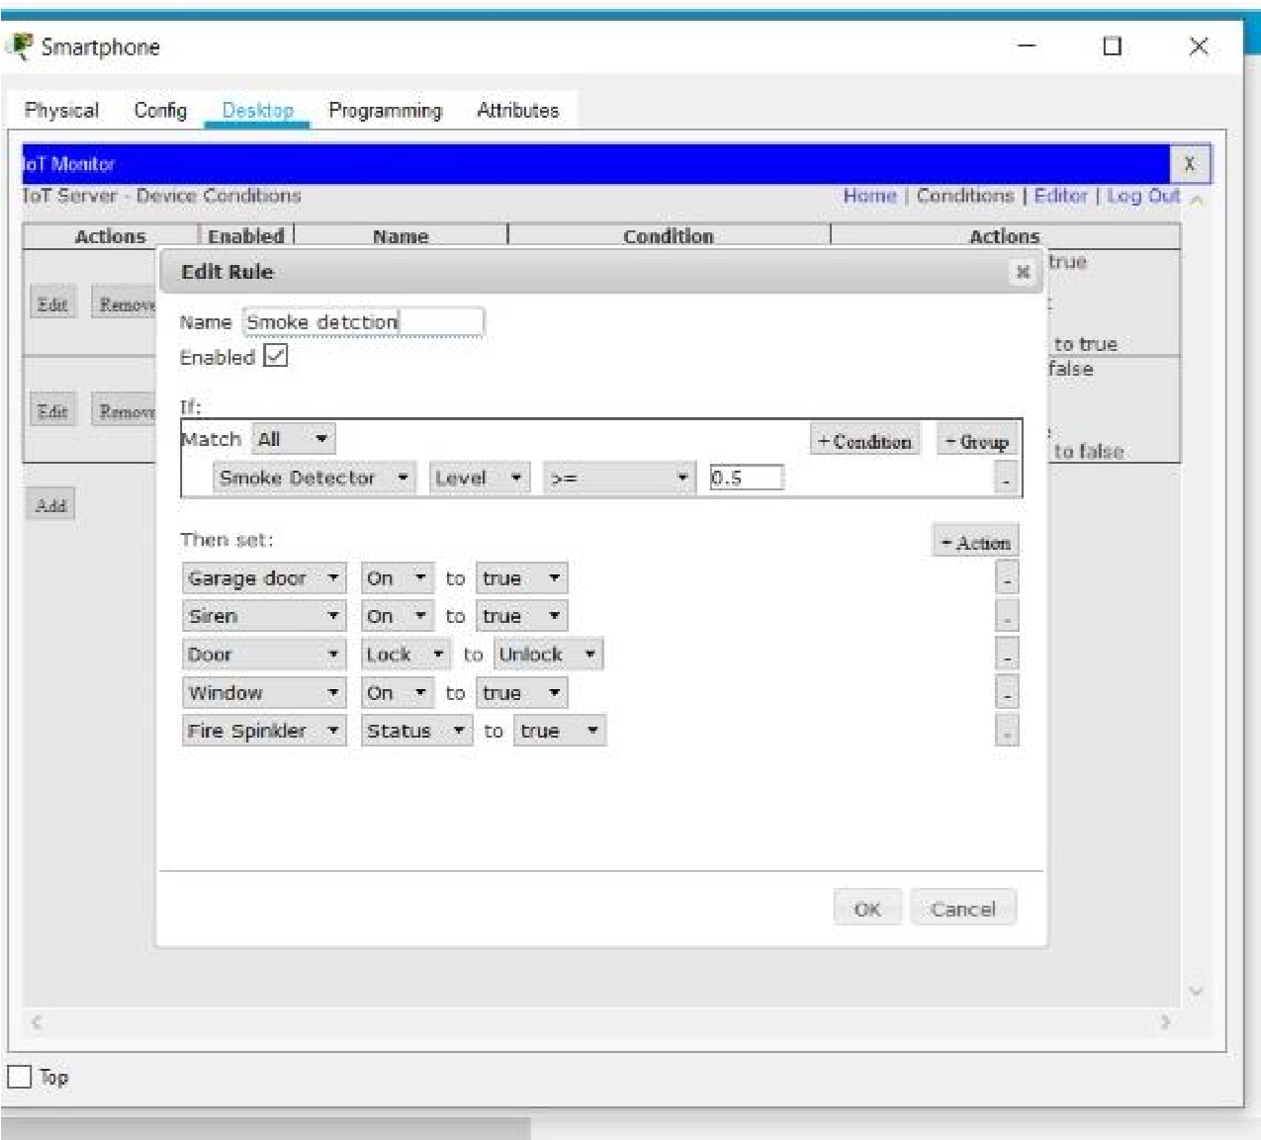

*Figure 4.2. Smoke Detector on Rules*

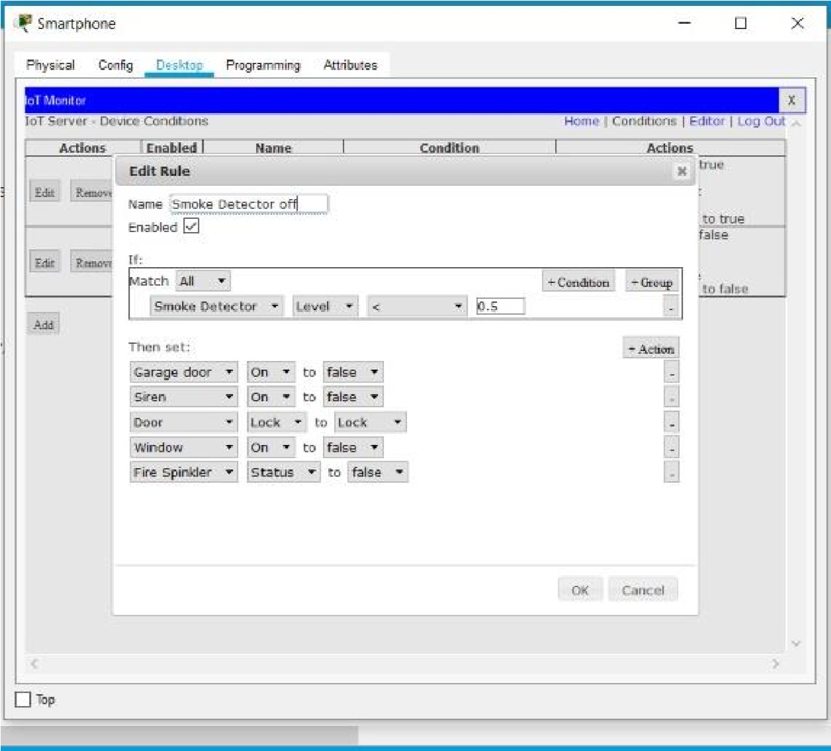

*Figure 4.3. Smoke Detector Off rules*

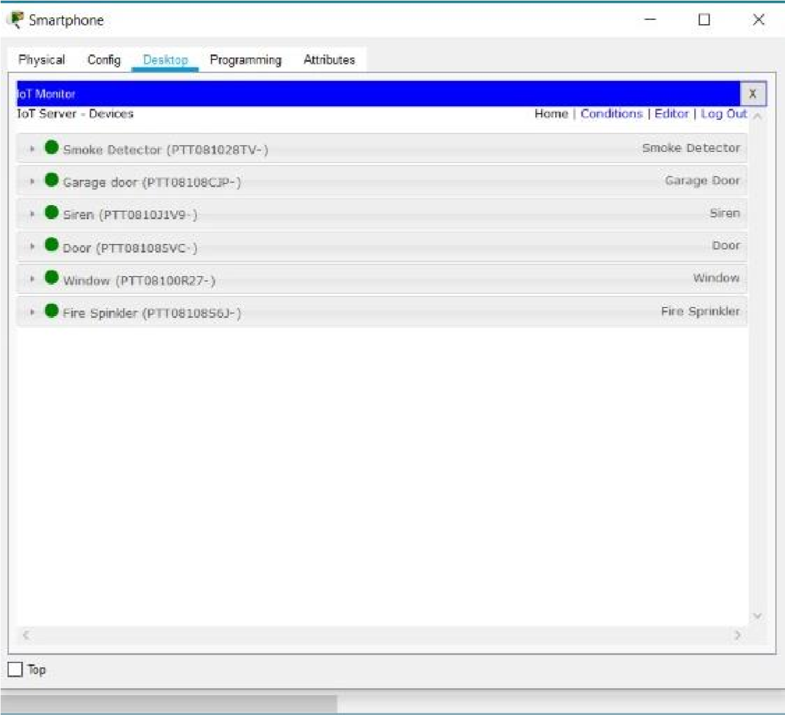

*Figure 4.4. Devices in the system*

**IMPLEMENTATION**

## 5.1. Network Design

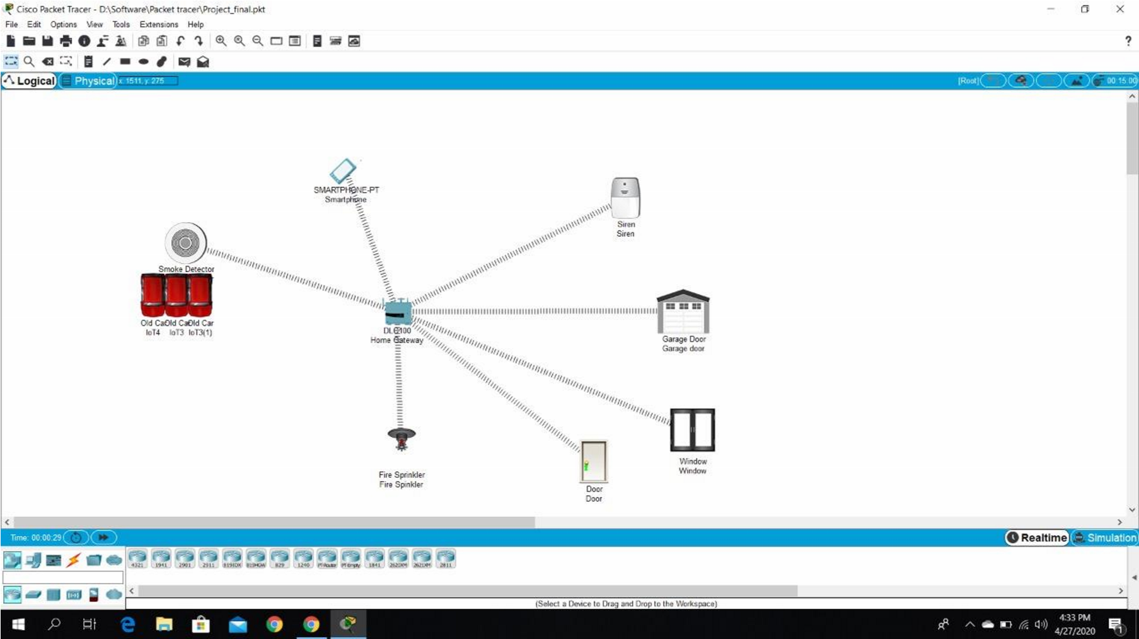

*Fig 5.1. Network Design (Before)*

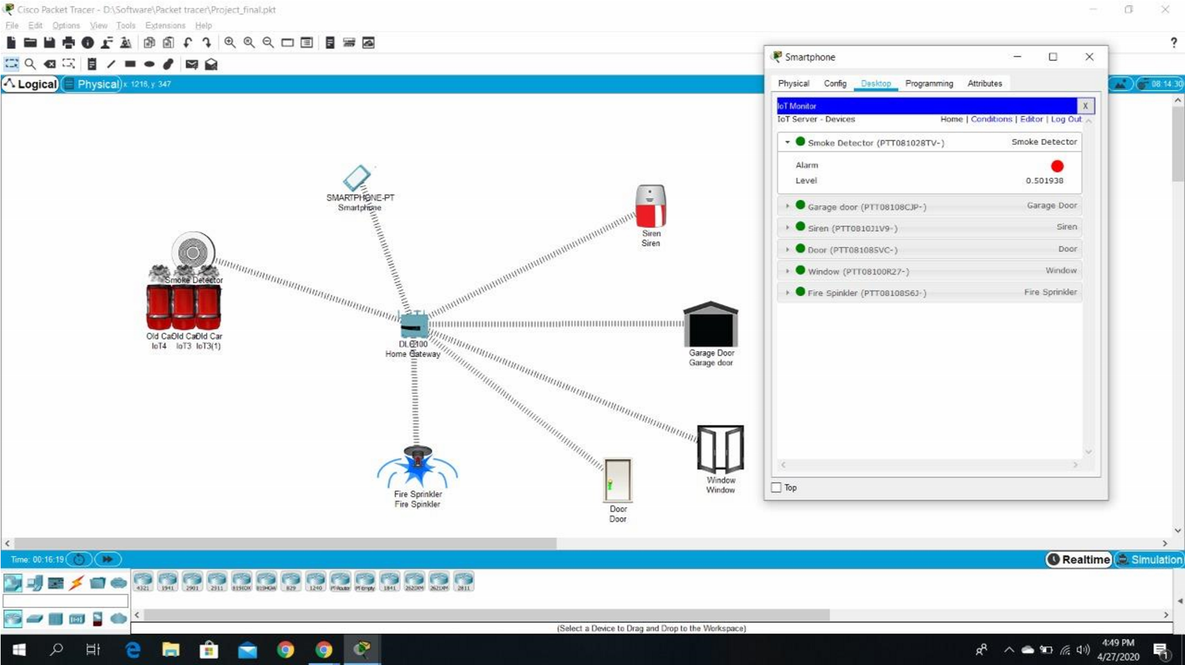

*Fig 5.2. Network Design (After)*

## 5.2. Configuration

1. **DLC Home Gateway** 
   * + Created a web page with username and password to connect and gain control of the system.
     + Registration can be done on this router.
     + Range of the router is set to maximum (1000 meters or 1km).
     + Ip address is assigned as 192.168.25.1 dynamically.

1. **Smartphone** 
   * + Connect to the system by going to the web browser and entering the IP of the registration server and logging in using ID and Password.
     + Ip address is assigned as 192.168.25.100 dynamically.

1. **Smoke Detector** 
   * + Smoke Detector is used to detect any smoke. E.g. When a fire breaks out the smoke detector will detect it. And in our project when the smoke level goes beyond 0.5, certain conditions are triggered such as door, windows are opened and fire sprinkler and siren are turned on.
     + It is connected to Home Gateway using advanced setting in I/O config i.e. (PT-IOT-NM-1W) network adapter setting.
     + Dynamic IP address is assigned using DHCP.

1. **Window** 
   * + A window is an opening in a wall that allows the passage of light, sound, and sometimes air.
     + It is connected to Home Gateway using advanced setting in I/O config i.e (PT-IOT-NM-1W) network adapter setting
     + Dynamic IP address is assigned using DHCP

1. **Door** 
   * + A door is an opening from where people can enter or leave in a normal routine life as well as in emergency.
     + It is connected to Home Gateway using advanced setting in I/O config i.e (PT-IOT-NM-1W) network adapter setting
     + Dynamic IP address is assigned using DHCP

1. **Garage door** 
   * A Garage door is an opening from where vehicles can enter or leave. In our case this is very crucial as garage doors are huge and can help the air escape when there is a fire outbreak, releasing carbon dioxide and other gases into the air and helping any people to take clean air if they are stuck in the house.
   * It is connected to Home Gateway using advanced setting in I/O config i.e. (PT-IOT-NM-1W) network adapter setting
   * Dynamic IP address is assigned using DHCP

1. **Fire sprinkler**

* The fire sprinkler sprays streams of water to suppress or extinguish the fire when ordered by the home gateway. This happens when smoke detector detects smoke level more than 0.5.
* It is connected to Home Gateway using advanced setting in I/O config i.e (PT-IOT-NM-1W) network adapter setting
* Dynamic IP address is assigned using DHCP

1. **Siren** 
   * A siren is device which makes a loud emergency sound when the smoke detector detects smoke level greater than 0.5.
   * It is connected to Home Gateway using advanced setting in I/O config i.e (PT-IOT-NM-1W) network adapter setting
   * Dynamic IP address is assigned using DHCP

1. **Car** 
   * In Cisco-packet tracer there is no object or entity which can simulate the generation of smoke other than a car.
   * So, we have used 3 cars to represent smoke generation which is similar to smoke generated during fire.

**Conditions:**

To implement the project, we need to specify certain conditions on which all the devices can be activated and deactivated. Based on how and when these conditions change, there will be changes in the state of the devices. To simulate smoke, we have used 3 cars. The conditions which are mentioned above and are crucial for this simulation are as follows:

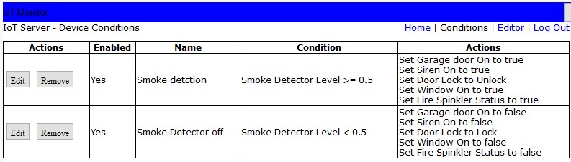

*Fig 4.3. System Conditions based on Situation*

**Testing and Deployment**

**Testing**

*Table 5.1. Test Cases*

|  |  |  |  |  |
| --- | --- | --- | --- | --- |
| **Test Case no.** | **Test Case** | **Expected Output** | **Actual Output** | **Result** |
| 1 | When smoke detector detects smoke level > 0.5 | Door open, window open, garage door open, sprinkler on, siren on. | Door open, window open, garage door open, sprinkler on, siren on. | Pass |
| 2 | When smoke detector detects smoke level < 0.5 | Door close, window close, garage door close, sprinkler off, siren off. | Door close, window close, garage door close, sprinkler off, siren off. | Pass |

**Deployment**

This system can be of great in domestic as well as industrial settings to detect smoke and alert people on an impending fire since smoke is a precursor for fire, instead of relying on heat/temperature sensors which sounds alarm when the fire has already started. This can go a long way in helping to save human life.

**Maintenance**

**User manual**

1. All the components must be regularly checked for proper working.
2. Based on the condition set, check whether all devices are working.
3. The Home gateway is up all the time.
4. Smoke Detector should be able to detect presence of smoke all the time.

**References**

* [https://www.packettracernetwork.com/internet-of-things/iot-advancedprogramming.html](https://www.packettracernetwork.com/internet-of-things/iot-advanced-programming.html)
* [https://www.packettracernetwork.com/internet-of-things/pt7-iot-devicesconfiguration.html](https://www.packettracernetwork.com/internet-of-things/pt7-iot-devices-configuration.html)
* [https://www.theseus.fi/bitstream/handle/10024/150158/Andrea%20Finardi%20%2](https://www.theseus.fi/bitstream/handle/10024/150158/Andrea%20Finardi%20%20Master%20of%20Engineering%20%20Information%20technology.pdf?sequence=1&isAllowed=y)

[0Master%20of%20Engineering%20%20Information%20technology.pdf?sequence=1 &isAllowed=y](https://www.theseus.fi/bitstream/handle/10024/150158/Andrea%20Finardi%20%20Master%20of%20Engineering%20%20Information%20technology.pdf?sequence=1&isAllowed=y)